Ninth Meeting of the Infrastructure Financing and Public-Private Partnerships (PPP) Network of Asia and the Pacific
The United Nations Economic and Social Commission for Asia and the Pacific (ESCAP) collaborated with the Asian Infrastructure Investment Bank (AIIB) to co-organize the ninth meeting of the Infrastructure Financing and Public-Private Partnerships (PPP) Network of Asia and the Pacific on 12-13 July,2023 in Beijing, China. The agenda of this meeting was to foster investment in sustainable infrastructure development across the Asia and Pacific region by leveraging effective infrastructure financing and PPP mechanisms.
The specific objectives of this Ninth Meeting were:
- Invite member States' PPP units to present sustainable infrastructure projects, supported by the Asian Infrastructure Investment Bank (AIIB), thereby facilitating opportunities for investment and development.
- Introduce and present the ESCAP PPP Guidelines to enhance ESCAP member States’ capacity to prepare and implement inclusive and climate-resilient infrastructure.
- Conduct site visits to infrastructure projects, providing participants with firsthand exposure to innovative and sustainable infrastructure initiatives in practice.
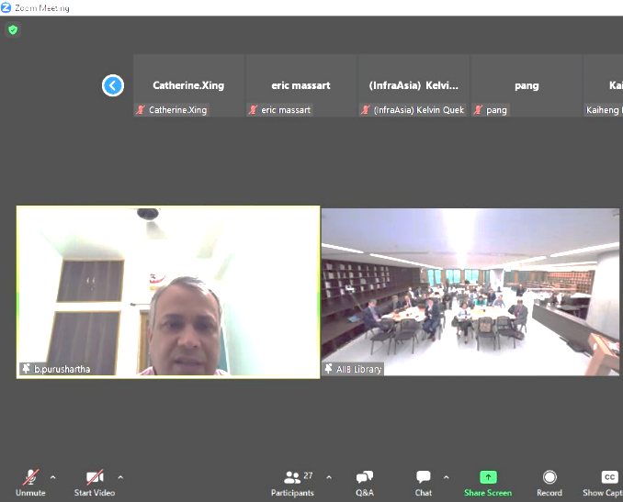
Mr. Baldeo Purushartha, Joint Secretary, IFS participated in the meeting, virtually and presented the project “Development of 6 Medical College & Hospital in unserved districts of Uttar Pradesh” as one of the sustainable infrastructure projects being implemented in healthcare sector in India.
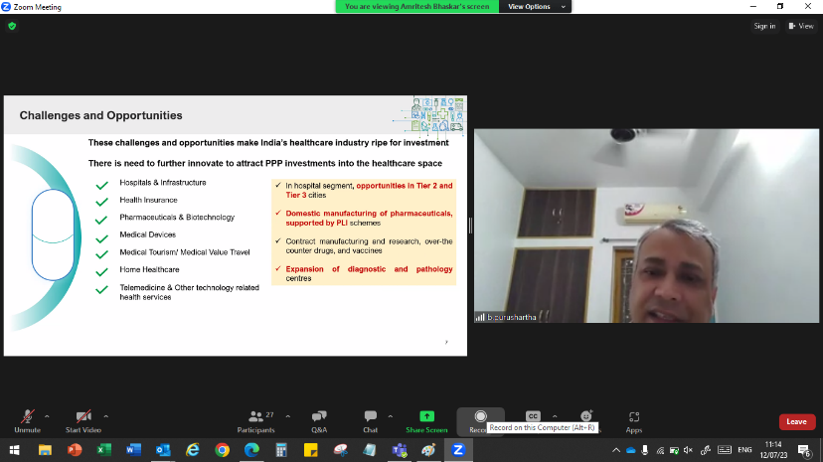
During the presentation, Mr. Baldeo highlighted the Challenges and Opportunities in Healthcare in India and further explained PPP in Healthcare and how Viability gap funding is being used to drive PPP uptake in healthcare. After explaining the VGF scheme, Mr. Baldeo provided details on the project background with justification, project structure, role of private and public parties and financial analysis of the project.
Shri Baldeo Purushartha presenting “UP Healthcare Project” at the UNESCAP-AIIB meeting
Shri Baldeo Purushartha highlighted the challenges and opportunities in Healthcare in India and how VGF is being used to drive PPP uptake in healthcare
Apart from India, Government representatives from landlocked countries in Asia like Mongolia, Philippines, Sri Lanka, Tajikistan, Kyrgyzstan also presented their bankable infrastructure projects with a strong emphasis on climate resilience and gender mainstreaming considerations.
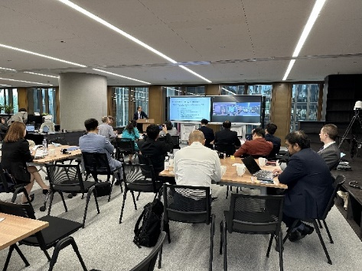
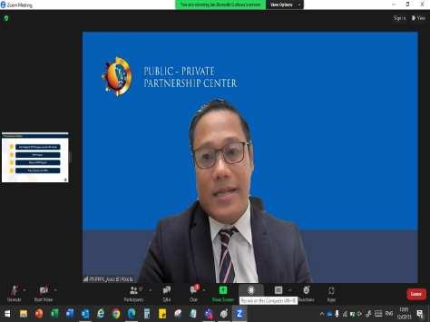
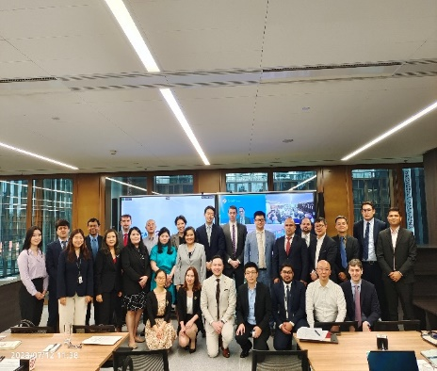

Government representatives presenting their Projects

